Step 1. Login to Ariba supplier account using login credentials.
Link to login – Supplier login page
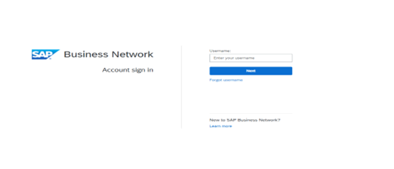

Step 2: - Find Application Gateway and Click on the Molex Apps
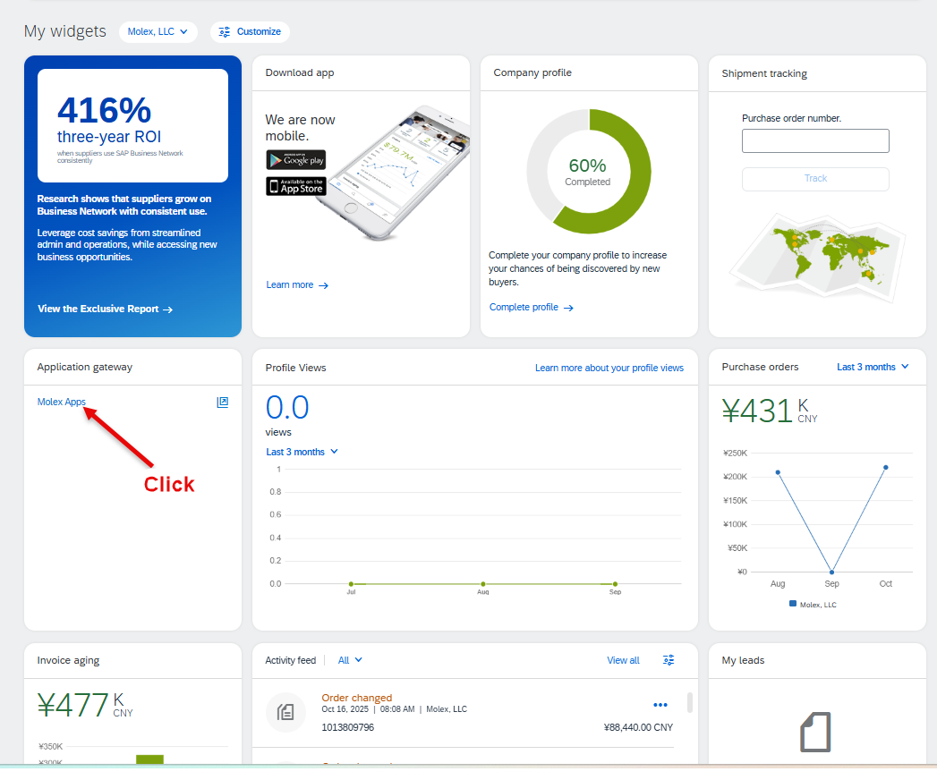
Step 3: - Click on Labeling in Homepage to access Label application
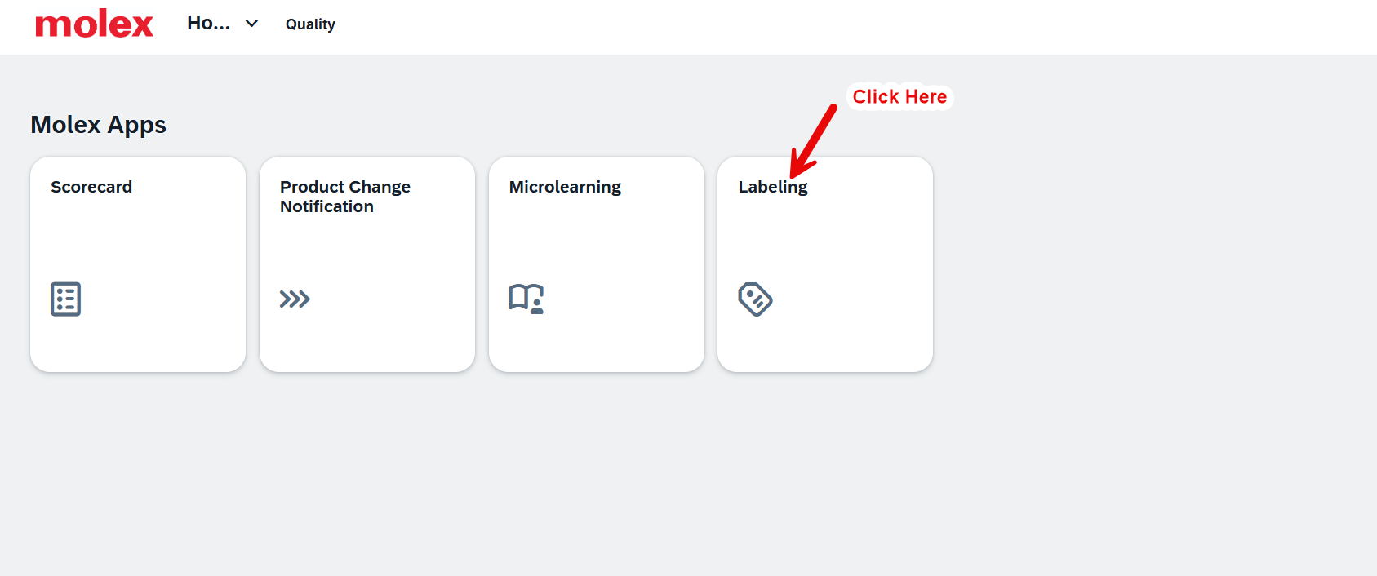

Step 4: - Homepage will Display all the open order lines.
Supplier can Search for Purchase Order (PO) and Material Number using search option
- Search for the PO number using search by PO number option.
- Search for PO number using search by material number option
- Setting Option
- Setting > Columns > Sort > Filters > Group.
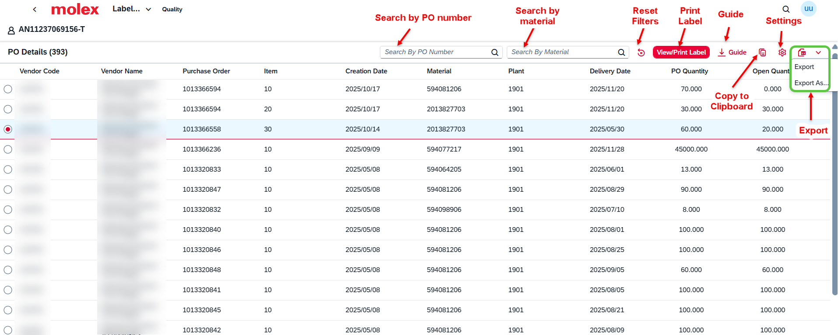
- Search for the PO number using search by PO number option.
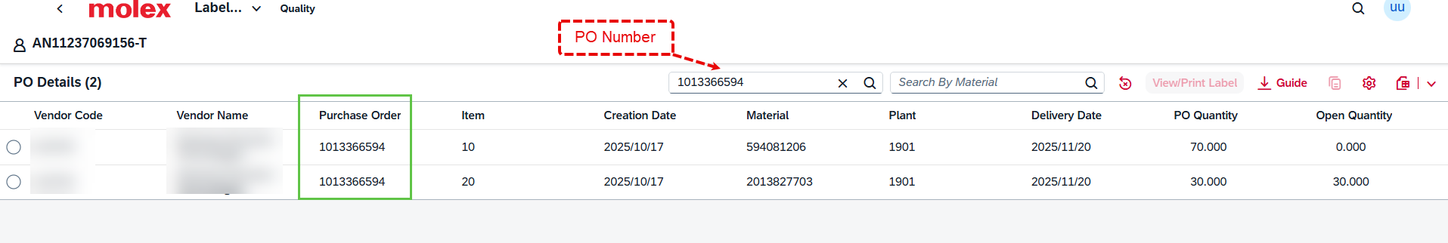
- Search for material number using search by material number option
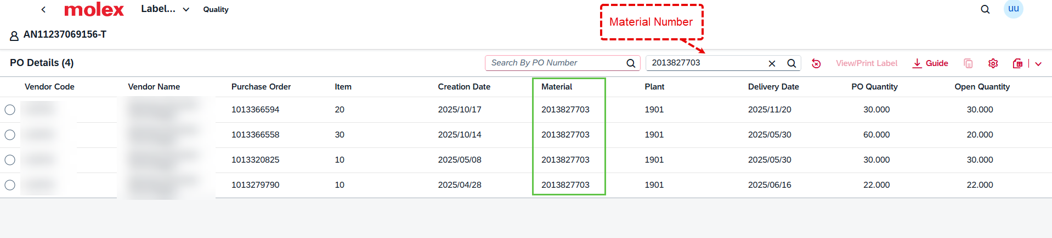
- Setting > Columns
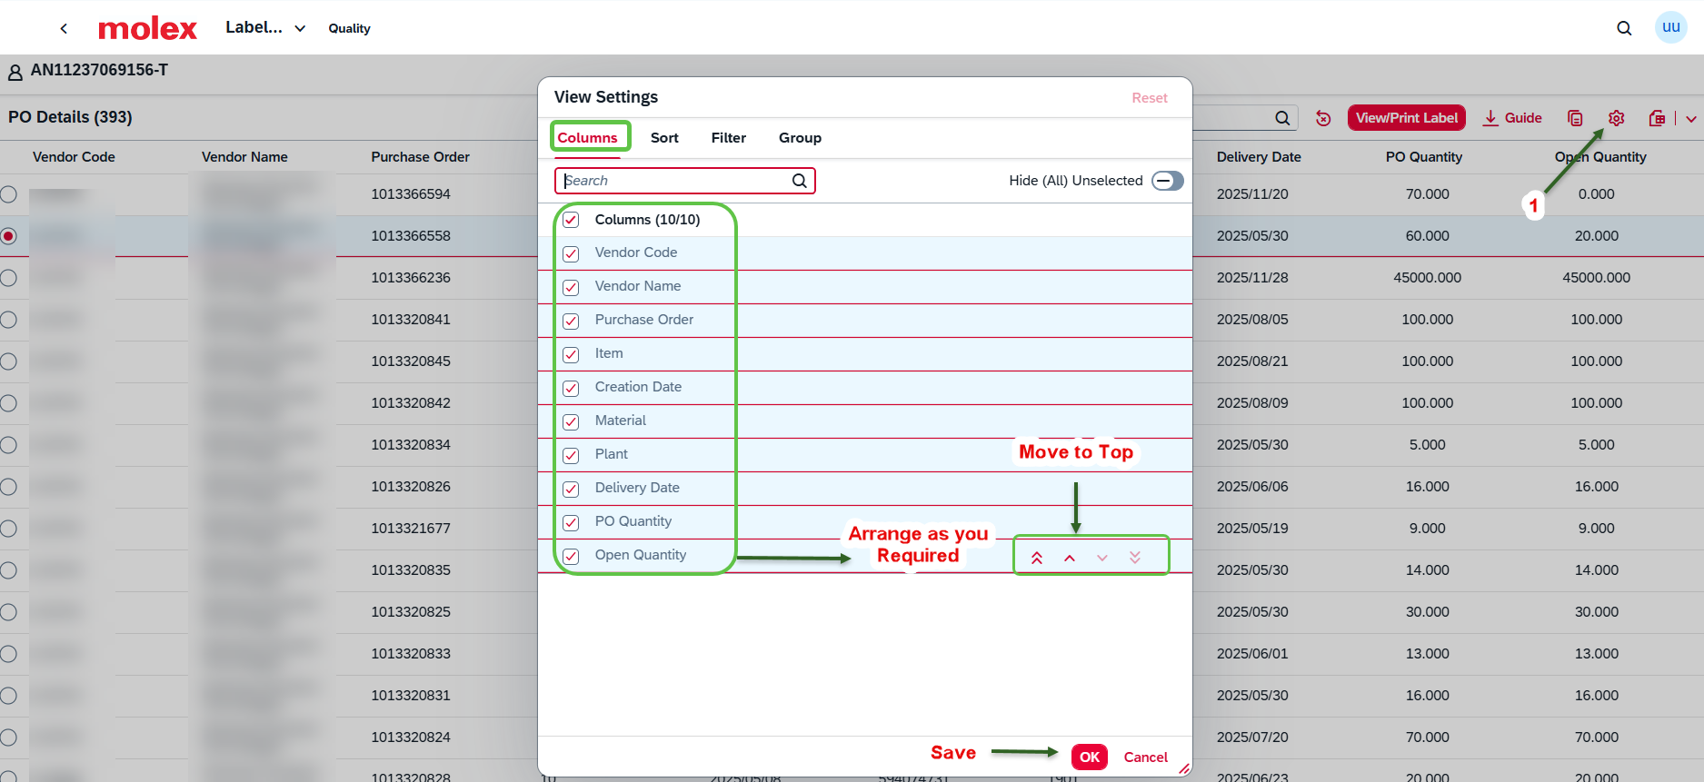
- Setting > Sort
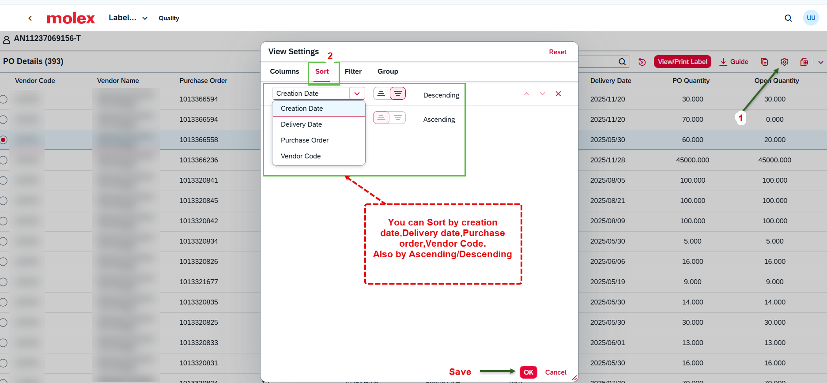

- Setting > Filters
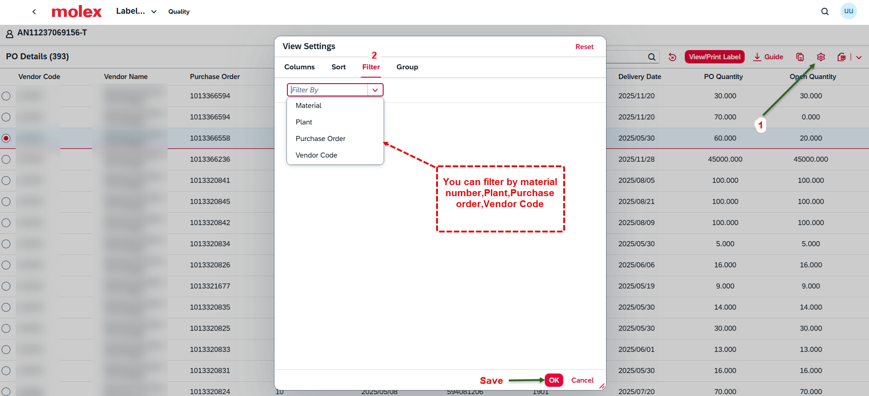

- Setting > Group
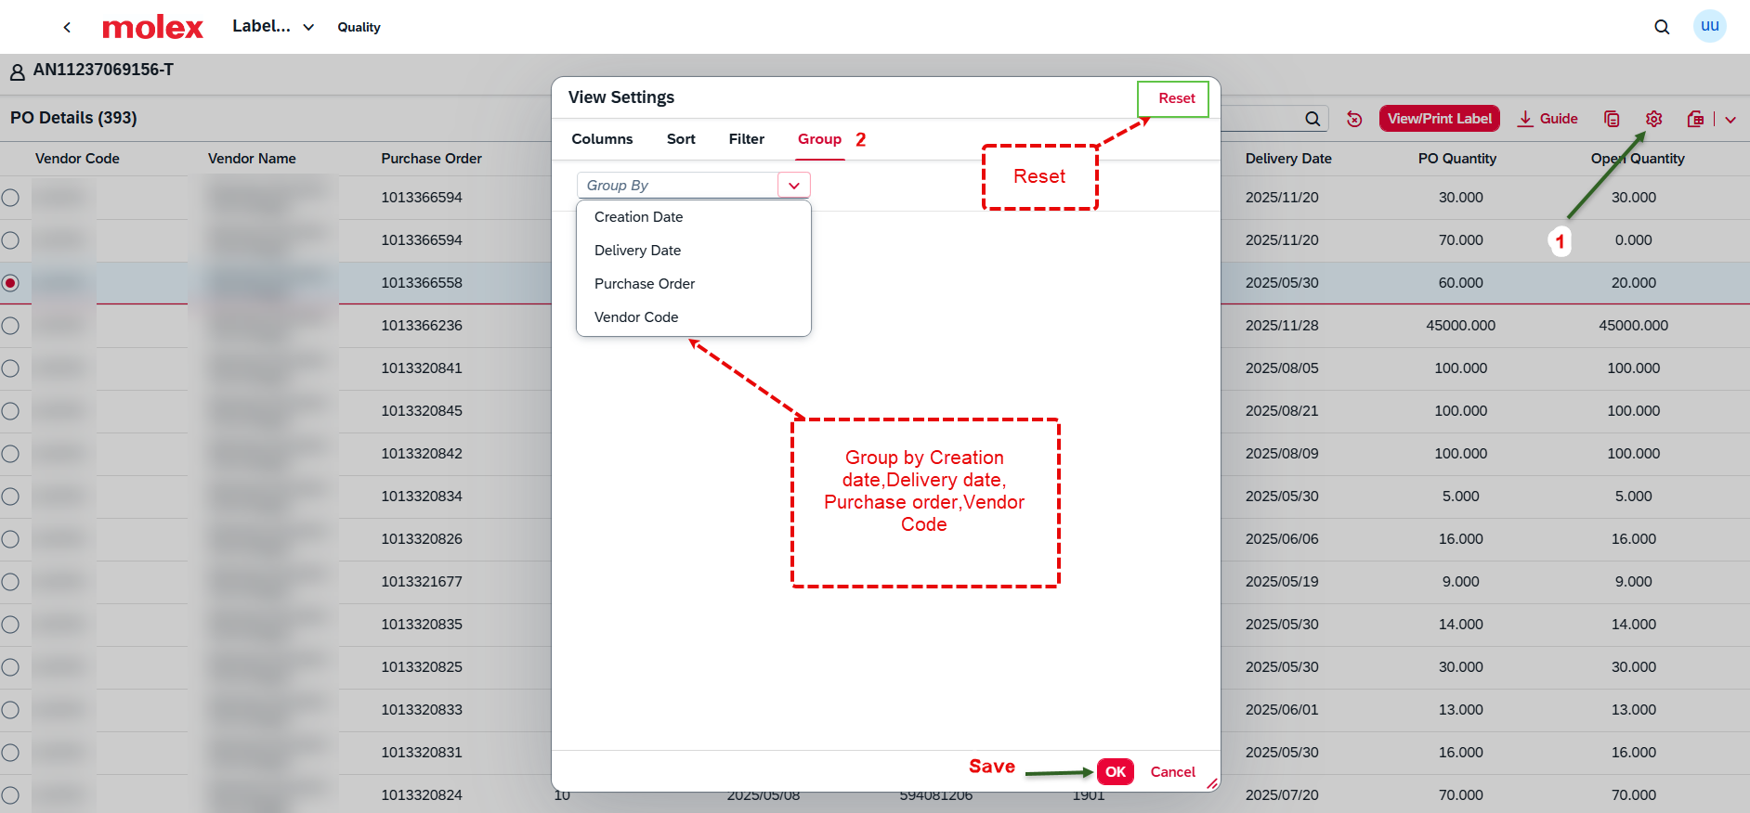

Step 5: To Print the label -> Select the PO line-> Click on View/Print label.
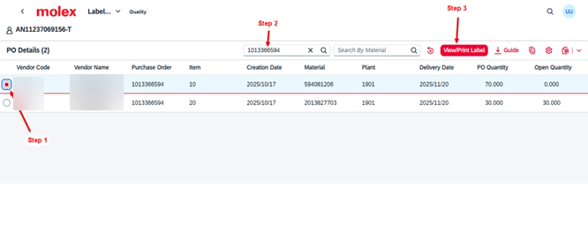

Step 6: Select the email ID to create the standard/ UL label based on the requirement.
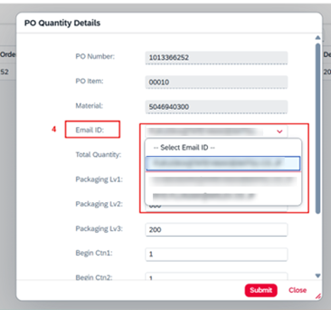
Step 7: Enter the remaining details like total quantity > Packaging Lv1,2,3 > Begin Ctn1,2,3 > Traceability details and click on submit.
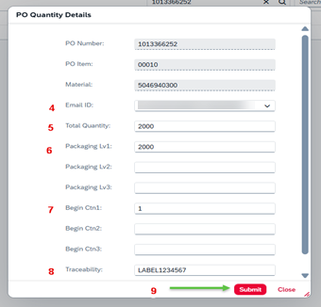

Step 8: Label will be generated, supplier can download label by using the download option

